Memo

Business Unit: | Business Consulting Services
To: | Shai Verma
From: | Harley Rodin
Date: | May 1, 2003
Pages: | 1
Subject: | Interview with Larry Latowsky, President & CEO Katz Group

** Confidential & Sensitive Material **

In an executive interview with Larry Latowsky on April 14, 2003, Shai Verma and Harley Rodin learned about the commitment and motivating factors for Katz Group Canada to establish best practices in Supply Chain Management as they craft themselves into four distinct chain/banner form factors that are interlinked and accountable for improved business practices. Katz is clearly maintaining their roots in the chain/banner retail pharmacy category and is positioning to increase market share organically and through the consumer loyalty shift away from the major competition that is trying to morph into mass/food merchandising.

The following notes highlight the results of our interview. Although a guideline with open questions was initially reviewed with Larry to set the context for this interview, there was more comfort in a natural discussion with relevant questions determined and answered as we progressed.

Our interview referred to slides in our initial presentation to the Katz Group Canada, where we asked Larry to relate Katz direction in this context. Each of the form factors that Katz is creating can be specifically mapped into this quadrant model with the overall position for Katz as described below.
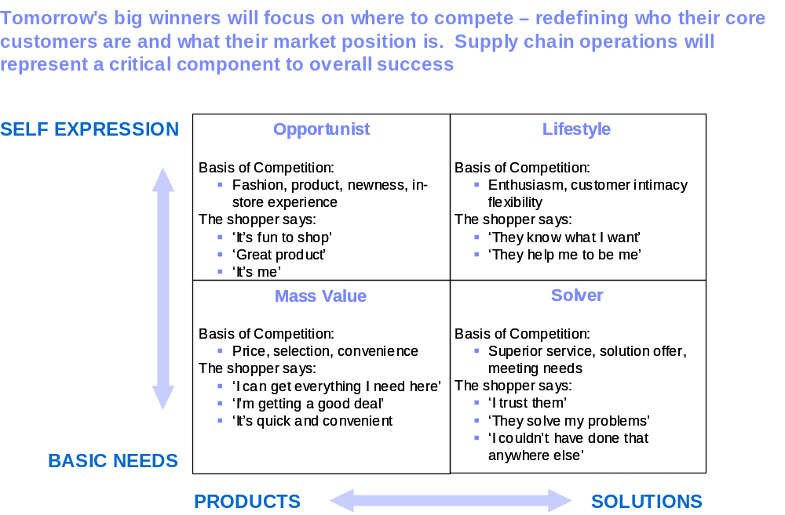



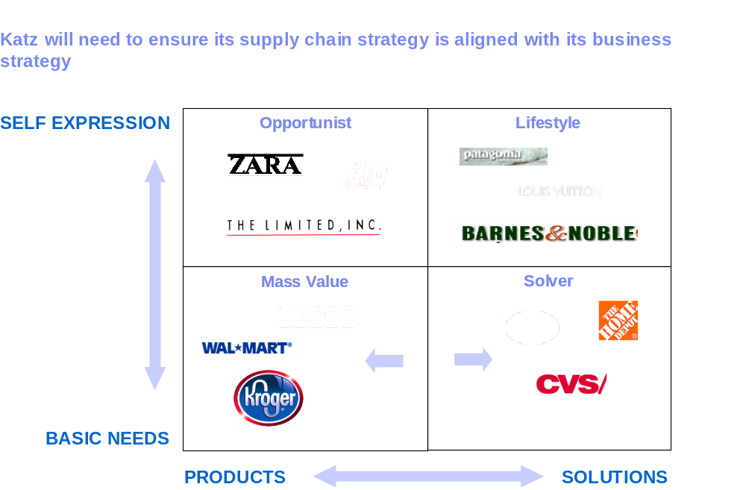

Larry’s Mandate

To take Katz to the next level maintaining their collective dominate position in Canadian Chain/Banner Drug Retailing and changing the personality of this market:

- Establish and maintain a world-class drug retail organization
- Control over their direction in a measurable and accountable fashion
- Be the largest integrated pharmacy network in Canada

- The core business for Katz is Retail Pharmacy
- Other business will evolve and be closely tied to Katz Retail Pharmacy through partnerships, ownership models, alliance and balance of control
- It is imperative that Katz deliver above average performance measured by ROA, EBITA, operations performance based on sales and other key operational elements
- Today, the driving force and measurements of Katz are convey through EBITA & ROA
- Katz is benchmarked against Publicly traded companies such as Shoppers Drug Mart, Jean Coteau (split between U.S. & Canada), major chains in the U.S.
- Katz measures themselves by market share data that describes revenue per square foot, category performance, customer counts, service levels, competitive impacts, etc. Katz subscribes to AC Nielson and IMS for this data. Much of this data is retroactive and based on shipping information rather than point-of-sale
- Internal objectives are measured operationally through employee retention, departmental growth. Merchandising objectives are determined by fulfillment in stock, service levels to meet customer demand
- Currently the majority of stores don’t measure inventory turns. They require perpetual inventory management. Larry places importance on stores being accountable to measure turns and will be driving this with other merchandise and operational measure requirements across the Katz chains.
- Business processes need to be standardized as decisions have a large impact. Katz is dependent on store level performance indicators and information generally which affect the P&L
- Larry emphasized, “Common information collected and mined through databases make good people great people”. Also, he emphasized that groups like Shoppers Drug Mart like a passenger, ‘Watch’ patient healthcare, as stated in the Healthwatch Brand. Katz’s mantra is ‘We Assist’ patient healthcare therefore Katz is active in patient preventative care and in managing medication therapy along with companion products that provide value and a great shopping experience for their customers.

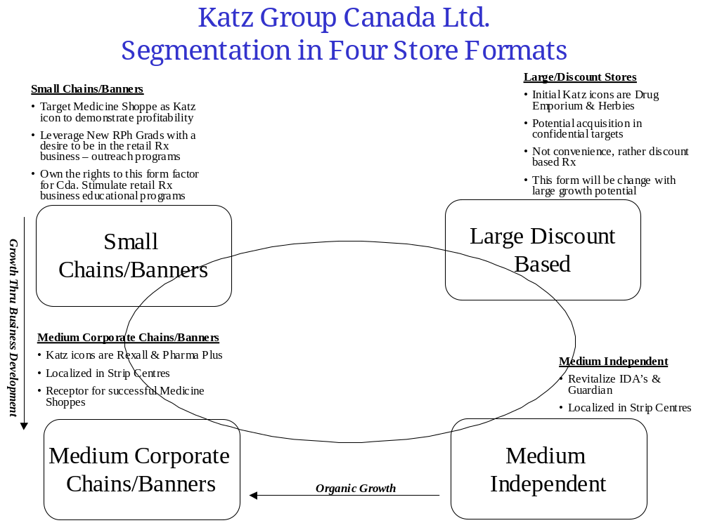
Focus on:
- Procurement,
- Supply Chain
- Category Management
Additional Key Messages from our Interview with Larry:

- The Rexall Private Label Brand is key to be leveraged across all formats
- Pharm Assist Brand from Pharma Plus will be the retail Rx mantra at Katz
- MediTrust mail order of refill chronic medications will remain in the arsenal of Katz positioning them for IPO as needed but it will not be expanded in form of central clearing, discounting, and will not be used for Preferred Provider (PPO) offerings
- PPO for the majority of Katz form factors would cause a downward spiral affect on the fee so is not being considered. However the Large Discount Based stores and acquisitions that Katz is considering will focus on drug discounting
- The Large Discount based stores will not focus on convenience rather the focus will be on discounting
- Katz will boost their presence in Private Label through their connections with manufactures of high-end, high-margin potential products e.g. cosmetics, neutraceuticals, etc.
- Propharm, Nexus Technology will be leveraged across Katz stores
- The Drug Trading concept will be tested on the Snyders banner to focus on services
- Katz has a long-term franchise based agreement for Medicine Shoppe. They see mature and profitable Medicine Shoppes through RPh graduates being developed and moved corporately where RPh grads will earn equity in the business for their attributed success
- McKesson/Medis will confidentially continue to supply stores until a better alternative capability can be created through centralized management of procurement, supply chain and category management
- Katz has a long-term agreement with McKesson. Katz realizes that their stores are very expensive to service and it is important to maintain their relationship with McKesson
- McKesson’s system of measuring Katz store’s inventory is not accurate and is retrospective based on shipments-in. McKesson is currently enabling Katz with the cash flow to sustain capital and promote Katz growth through acquisitions

